MASA-Bot: A Fine-Tuned Conversational AI for
Industry-Specific Query Resolution in Tourism & Hospitality
A Capstone Research Paper
Author: Santosh Kumar
Program: Masters in Data Science
Institutional Affiliation: AlmaBetter
Date of Submission: September 17, 2026

Abstract
Hotels in the Tourism & Hospitality industry handle a large volume of repetitive customer queries every day — about bookings, cancellations, meal plans, and policies — which is costly and slow to manage manually. This project addresses that problem by fine-tuning DistilGPT2, a lightweight pretrained language model from Hugging Face, on a custom set of 72 Q&A pairs covering these exact query types, using the Trainer API on Google Colab over 25 epochs. To ground the bot's context in real industry behaviour, the project also performs exploratory data analysis on 119,390 real hotel-booking records, finding that cancellation rate rises from 10.98% for bookings made within a week of arrival to 67.66% for bookings made 365 or more days in advance.
After fine-tuning, the model achieved a final validation loss of 3.4259 and a perplexity of 30.75. The training loss decreased steadily and consistently across all 25 epochs, while validation loss rose after an initial dip, indicating some overfitting to the small 72-pair dataset -- an expected limitation given the dataset's size, discussed further in Section 6.
Keywords: Conversational AI, LLM Fine-Tuning, Hugging Face, Tourism & Hospitality, DistilGPT2, NLP

1. Introduction

1.1 Background
With the rapid advancement of Large Language Models (LLMs), AI systems have become increasingly capable of understanding and generating human-like text. The Tourism & Hospitality industry, in particular, faces a significant operational challenge: hotels handle a large volume of repetitive customer queries every day, ranging from bookings and cancellations to meal plans and hotel policies. Managing these manually increases both staff workload and operational cost, creating a strong practical need for automation.
This industry was chosen for the present study because customer queries within it tend to be highly repetitive and domain-specific in nature. This characteristic makes it particularly well suited to a specialized conversational AI system, where a model trained on a focused set of domain queries can plausibly provide accurate, consistent responses without requiring general-purpose intelligence.

1.2 Problem Statement / Research Question
This study is guided by the following research questions:
- Can a lightweight, fine-tuned LLM (DistilGPT2) answer hospitality-specific queries accurately and coherently?
- Does fine-tuning on a small, custom, industry-grounded dataset outperform a generic pretrained model on domain-specific queries?

1.3 Objectives
- Build a Tourism & Hospitality conversational Q&A dataset.
- Fine-tune a Hugging Face pretrained model on this dataset.
- Test bot responses and evaluate with loss/perplexity metrics.
- Perform supporting EDA on real hotel-booking data (119,390 records) to understand industry patterns.

1.4 Significance
This research has both practical and academic significance. Practically, it demonstrates a path toward automating hospitality customer support, which can reduce response time and staff workload for routine, repetitive queries. Academically, it shows how effective small-scale, domain-specific fine-tuning can be even on a resource-constrained setup (a single Colab GPU/CPU and a 72-pair dataset), rather than requiring large-scale infrastructure.

2. Industry Analysis

2.1 Industry Overview & Current Trends
The global tourism industry has fully recovered from the COVID-19 pandemic: international tourist arrivals reached an estimated 1.4 billion in 2024, about 99% of pre-pandemic (2019) levels, while tourism export revenues hit a record USD 1.9 trillion, roughly 3% above 2019 (UN Tourism, World Tourism Barometer, January 2025). This recovery has been accompanied by structural changes in how travelers book and interact with hospitality providers — most notably, growing reliance on digital and AI-driven customer service.
- Rising adoption of AI chatbots in hotels for 24/7 customer support.
- Growing personalization — recommending room type/meal plans based on guest preference.
- Dynamic pricing (ADR) responding to demand fluctuations.

2.2 Data-Backed Industry Insight (from this project's EDA)
Two real datasets were used in this study. The first, Hotel_Bookings (119,390 records), provides the hospitality/booking side of the industry (analysed below in Section 2.2.1). The second, the Indonesia Tourism Destination dataset (Kaggle: aprabowo/indonesia-tourism-destination — 437 destinations, 300 users, 10,000 ratings, and curated travel packages), provides the tourism/destination side (Section 2.2.2).

2.2.1 Hotel Booking Patterns
The following statistics were computed directly from the Hotel_Bookings dataset (119,390 records) used in this study:
Lead-Time Bucket | Cancellation Rate
0-7 days | 10.98%
8-30 days | 27.86%
31-90 days | 37.70%
91-180 days | 44.71%
181-365 days | 55.45%
365+ days | 67.66%
Overall cancellation rate across all bookings: 37.04%. Lead time shows the strongest positive correlation with cancellation (r = 0.293), followed by previous cancellations (r = 0.110). Mean ADR = 101.83, Median ADR = 94.58; correlation between ADR and lead time is weak and negative (r = -0.063).
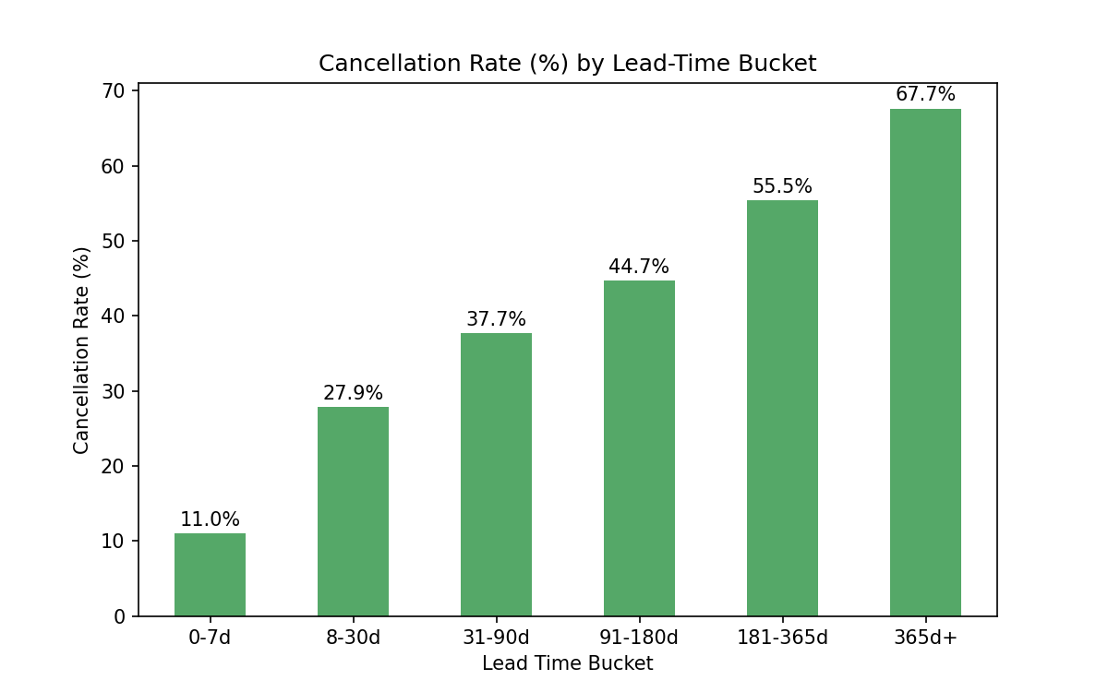
Figure 1: Cancellation Rate (%) by Lead-Time Bucket
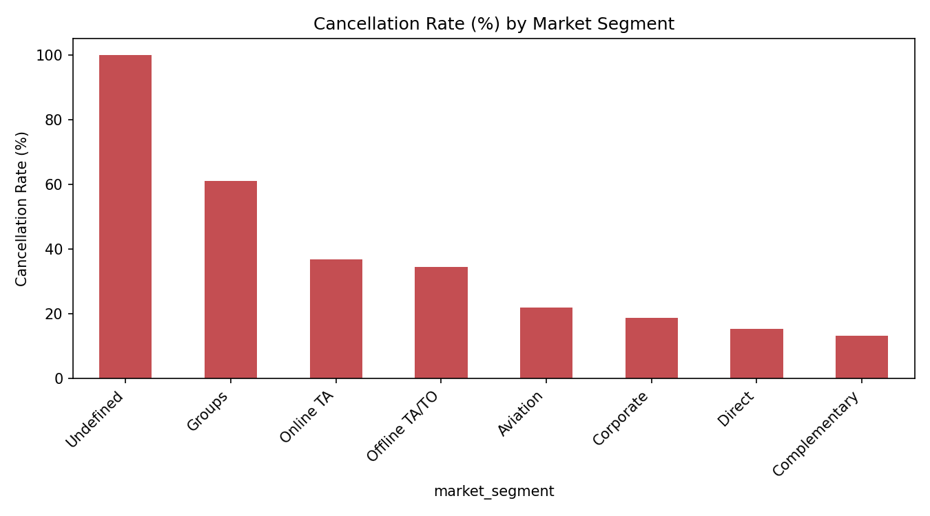
Figure 2: Cancellation Rate (%) by Market Segment
These two charts point to two practical levers for hotels. First, the near-linear rise in cancellation rate with lead time (Figure 1) means hotels can flag long-lead-time bookings as higher-risk and apply stricter deposit terms to protect revenue. Second, the market-segment breakdown (Figure 2) shows that channel matters as much as timing — Group and Online-TA bookings cancel roughly 2-4x more often than Direct or Complementary bookings — suggesting hotels should invest in direct-booking incentives and closer follow-up with high-cancellation channels.

2.2.2 Tourism Destination Patterns
The 437 destinations span 6 categories — Taman Hiburan/Amusement Parks (135), Budaya/Culture (117), Cagar Alam/Nature Reserves (106), Bahari/Marine (47), Tempat Ibadah/Places of Worship (17), and Pusat Perbelanjaan/Shopping Centers (15) — concentrated mainly in Yogyakarta (126), Bandung (124), and Jakarta (84). Overall place ratings (curated) average 4.44/5, while individual user ratings (10,000 entries) average around 3.0/5 — a gap suggesting curated listings skew toward well-regarded places, while individual visitor experiences vary more widely. Price and rating show almost no correlation (r = 0.023), meaning higher-priced attractions are not perceived as meaningfully better than free or low-cost ones. 137 of the 437 destinations (about 31%) are free to enter, mostly places of worship and public parks.
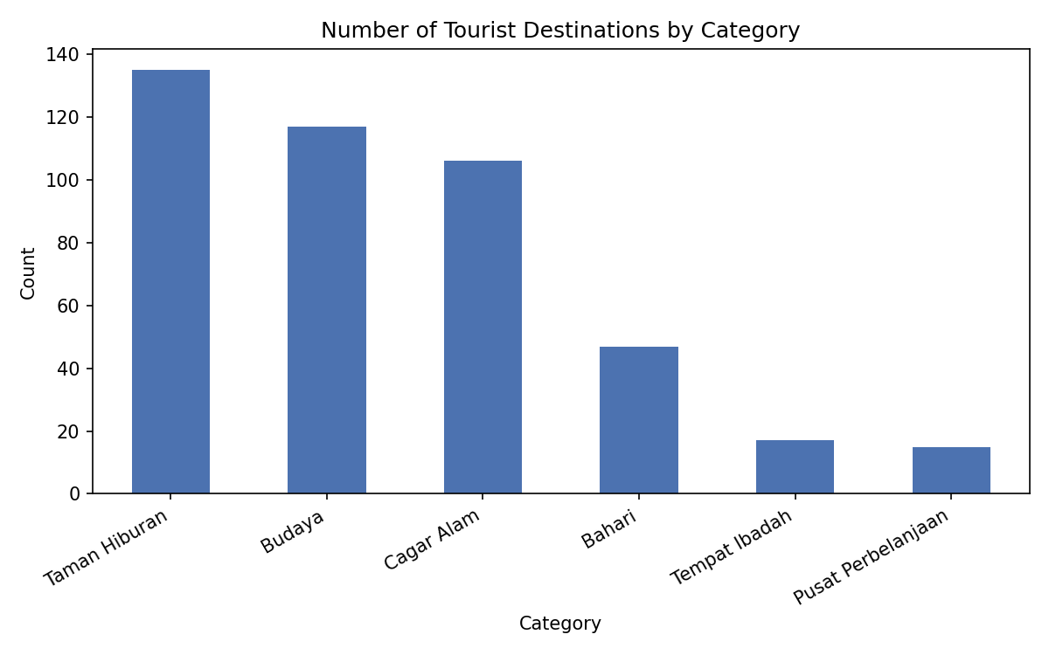
Figure 5: Number of Tourist Destinations by Category
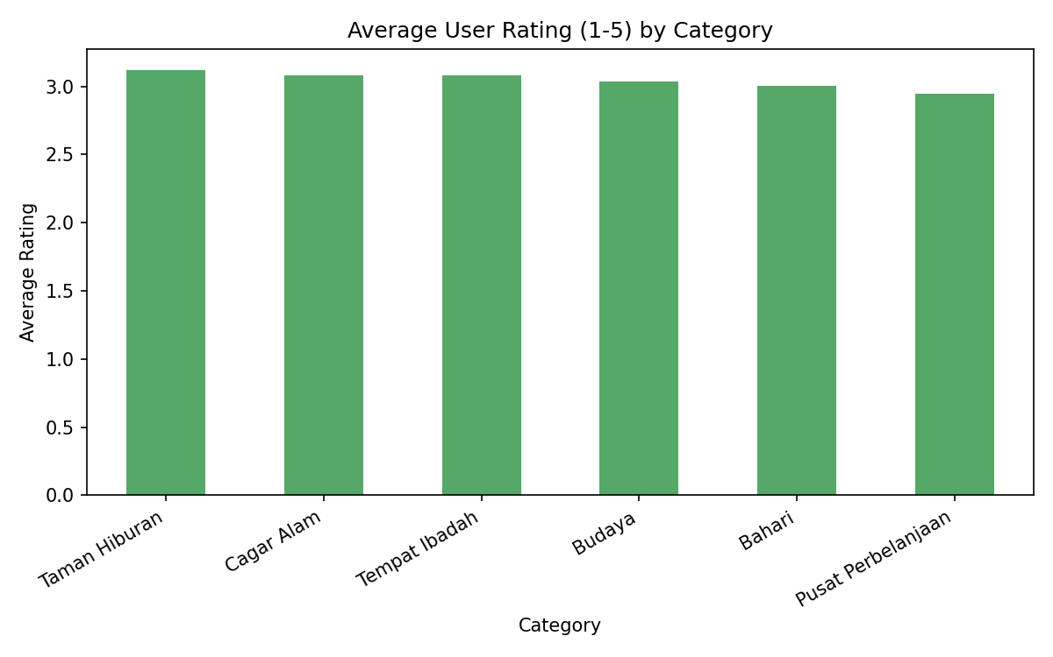
Figure 6: Average User Rating by Category
Taken together, these charts suggest that popularity (in terms of number of listed destinations) does not track cleanly with visitor satisfaction: Amusement Parks are the most numerous category (135 places) but do not top the average-rating chart, while smaller categories can rate just as well or better. Combined with the near-zero price-rating correlation, this indicates that for a conversational bot or a hospitality business alike, recommending or investing based on category popularity alone would be misleading — actual guest ratings are a better signal of quality than either category size or price.

2.3 Industry Requirements & How This Research Addresses Them
- Hotels need: instant responses, consistent policy information, 24/7 availability.
- This bot addresses these needs by providing automated, consistent answers to common queries.
- Profitability link: automation reduces staff costs; better response times improve guest satisfaction and repeat bookings.

3. Literature Review
This review covers six works spanning LLM-agent frameworks, the Transformer architecture, and model distillation, each contributing a different piece of the foundation for this project.
- Wu et al. (2024) — MathChat: Converse to Tackle Challenging Math Problems with LLM Agents. Shows conversational, multi-turn agent frameworks outperform single-prompt approaches.
- Hong et al. (2024) — Data Interpreter: An LLM Agent for Data Science. Demonstrates dynamic planning and verification make LLM agents more reliable for data-heavy tasks.
- Vaswani et al. (2017) — Attention Is All You Need. Foundational Transformer architecture underlying GPT/BERT-family models.
- Radford et al. (2019) — Language Models are Unsupervised Multitask Learners (GPT-2). Original paper for the base model family used in this project.
- Wolf et al. (2020) — Transformers: State-of-the-Art Natural Language Processing. The Hugging Face library paper enabling accessible fine-tuning.
- Sanh et al. (2019) — DistilBERT: A Distilled Version of BERT. Explains the distillation approach behind DistilGPT2.
- Kabir, M. R., et al. (2025). Two decades of chatbot research in tourism and hospitality: Bibliometric analysis and future directions. Tourism & Hospitality, published online 29 Apr 2025. Reviews 398 documents (2003-2023), showing chatbot adoption in the sector has grown from basic automation toward LLM-based, personalized, generative systems since 2023.
- Zaki, H. S., & Al-Romeedy, B. S. (2024). Chatbot symbolic recovery and customer forgiveness: A moderated mediation model. Journal of Hospitality and Tourism Technology, 15(4), 610-628.
Among these, Radford et al. (2019) — the original GPT-2 paper — is the most directly relevant to this study, since the present project fine-tunes DistilGPT2, a distilled variant of that same GPT-2 family, adapting a general-purpose pretrained language model to a domain-specific Q&A setting through supervised fine-tuning. The remaining works informed complementary aspects: Wu et al. (2024) and Hong et al. (2024) illustrate how conversational, multi-step LLM-agent frameworks can outperform single-prompt approaches, motivating the Q&A conversational format adopted here; Vaswani et al. (2017) provides the underlying Transformer architecture; Wolf et al. (2020) enabled the practical fine-tuning workflow via the Hugging Face ecosystem; and Sanh et al. (2019) explains the distillation technique behind DistilGPT2 itself.

Identified Gaps
- Most existing research targets general-purpose chatbots; tourism/hospitality-specific small fine-tuned models are less explored.
- Lightweight models (DistilGPT2) on small custom datasets are under-studied compared to large-scale efforts.
- This research addresses that gap by building a domain-specific bot in a resource-constrained setting (a free-tier Google Colab notebook, GPU or CPU).

Theoretical Framework
- Transfer learning — reusing a pretrained model's general language knowledge for a new domain.
- Supervised fine-tuning paradigm on task-specific data.

4. Methodology

4.1 Research Design
This is an applied/experimental study: a pretrained LLM was fine-tuned on custom domain data and evaluated using both qualitative (response quality) and quantitative (loss, perplexity) measures.

4.2 Data Collection
- Primary dataset: 72 Q&A pairs — 59 hand-crafted pairs covering booking, cancellation policy, meal plans (BB/HB/FB/SC), deposit types, and customer types, plus 13 pairs generated directly from the real tourism destination dataset (categories, cities, pricing).
- Supporting datasets: (1) Hotel_Bookings.csv — 119,390 real hotel booking records; (2) Indonesia Tourism Destination dataset (Kaggle: aprabowo/indonesia-tourism-destination) — 437 destinations, 300 users, 10,000 ratings, and curated packages. Together these ground the study in both the hospitality (booking/cancellation) and tourism (destination/rating) sides of the industry, and are used for the analysis in Section 2.2.

4.3 Data Preprocessing
- Q&A pairs formatted for causal language modeling: 'Q: <question>\nA: <answer><|endoftext|>'.
- Train/validation split: 85% / 15%.
- Tokenization with max length 128 tokens, padding and truncation applied.
- Missing values in Hotel_Bookings (country, children, agent, company) filled with mode/0.

4.4 Model Selection
DistilGPT2 was selected — a distilled, lightweight version of GPT-2 that fine-tunes quickly on limited hardware (GPU or even CPU, given the small dataset size) while retaining coherent text generation, loaded via the Hugging Face transformers library.

4.5 Fine-Tuning Setup
Hyperparameter | Value
Framework | Hugging Face Trainer API
Hardware | Google Colab (GPU if available, else CPU)
Epochs | 25
Batch size | 4
Learning rate | 5e-5
Weight decay | 0.01

4.6 Evaluation Method
- Training vs. validation loss curve plotted per epoch to check convergence.
- Perplexity score computed (exp of validation loss).
- Bot manually evaluated on 5 test questions for relevance and coherence.

4.7 Code & Tools
Full code implementation is available at: https://github.com/sant8ntl-max/Reserch-_in_Tourism-hospitality_ChatBot

5. Results

5.1 Supporting Industry EDA Results
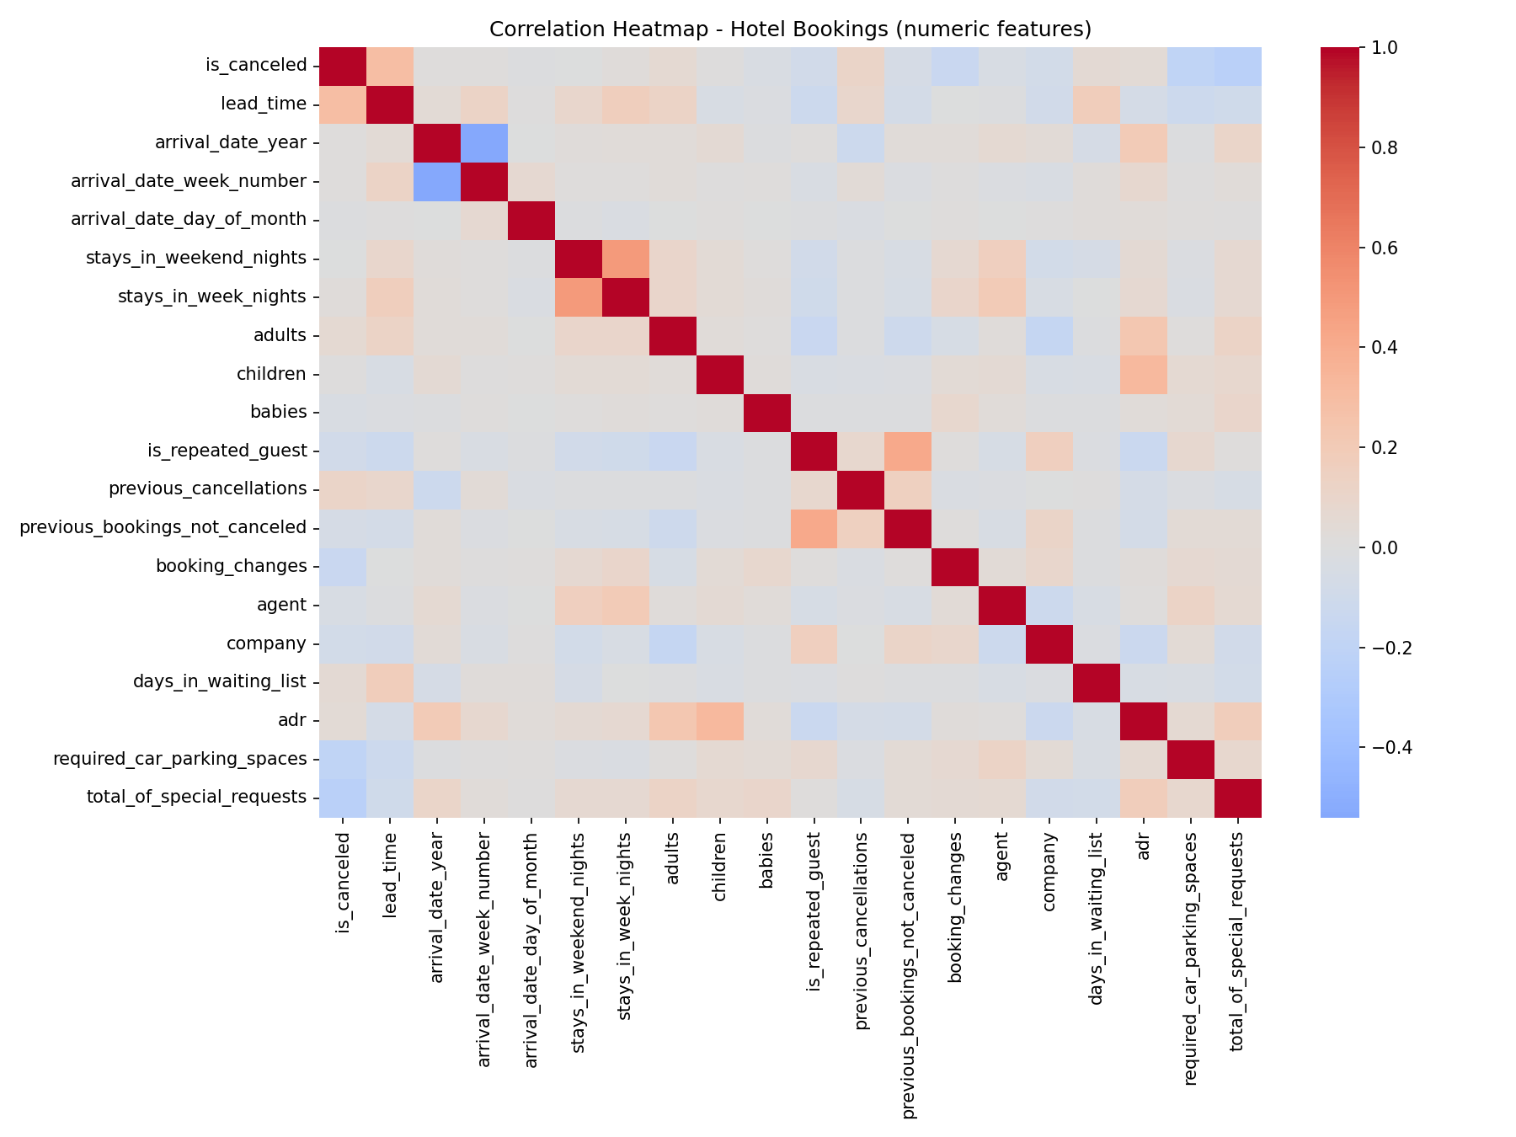
Figure 3: Correlation Heatmap — Hotel Bookings (numeric features)
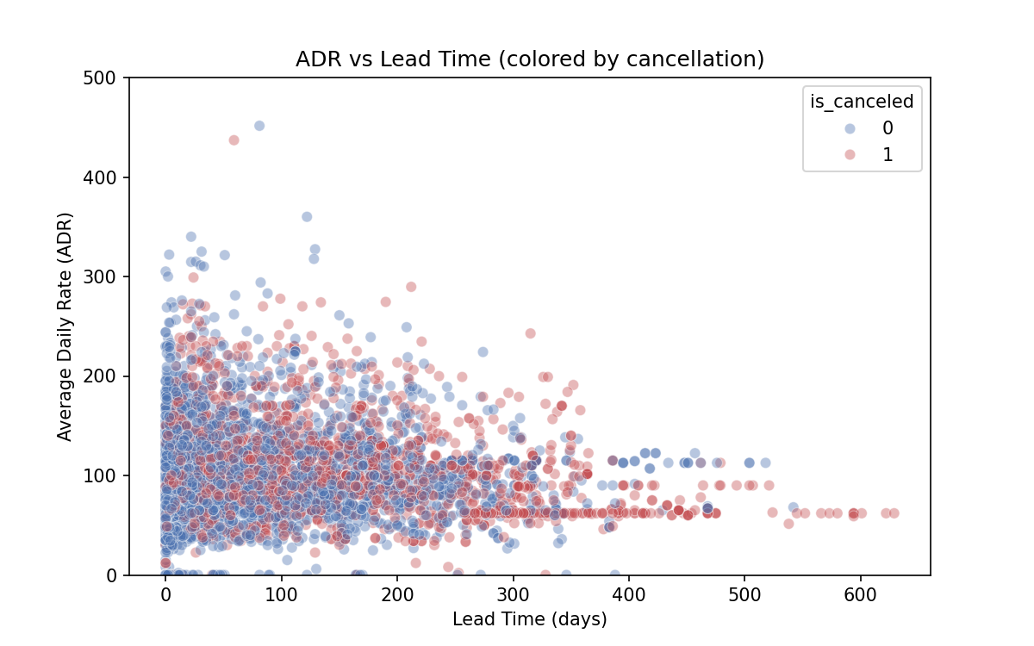
Figure 4: ADR vs Lead Time (colored by cancellation)
The correlation heatmap confirms that no single numeric feature dominates cancellation behaviour — lead_time (r = 0.293) and previous_cancellations (r = 0.110) stand out as the strongest, but both are modest in absolute terms, meaning cancellation is better explained by a combination of factors (including categorical ones like market segment) than by any one number alone. The ADR-vs-lead-time scatter shows cancelled bookings (orange) scattered across the full price range rather than clustered at high or low ADR, reinforcing that price alone is a weak predictor of cancellation — consistent with the near-zero correlation (r = -0.063) reported in Section 2.2.1.

5.2 Fine-Tuning Performance
The model was fine-tuned for the full 25 epochs. Training loss decreased steadily and consistently throughout, from roughly 3.2 at epoch 1 to about 0.2 by epoch 25 -- indicating the model learned the training Q&A pairs very well. Validation loss, however, dipped briefly to around 2.3-2.5 in the first few epochs before rising steadily for the rest of training, reaching a final value of 3.4259 (perplexity 30.75).
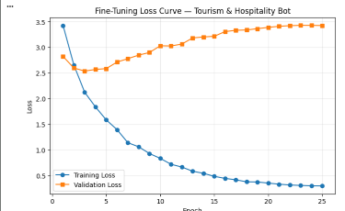
Figure 7: Training vs. Validation Loss over 25 Epochs
This divergence between training and validation loss -- training loss falling continuously while validation loss rises after an early minimum -- is a classic overfitting signature. It is an expected outcome given the small dataset (72 Q&A pairs): the model has enough capacity to memorize the training examples almost exactly, but this memorization does not generalize to the held-out validation examples. This is discussed further as a limitation in Section 6.

5.3 Bot Response Samples
Question | Bot's Answer (actual output) | Comment
What is your cancellation policy? | "Cancellations are subject to an individual's specific cancellation policy..." (phrase repeats in a loop until the token limit is reached) | Topically relevant but degenerates into repetition -- a known failure mode of small fine-tuned LMs, consistent with the overfitting seen in Section 5.2.
Do you offer airport transfer service? | "Yes, airport transfer is free and is" (cuts off mid-sentence) | Correct in direction (matches the training answer's intent) but grammatically incomplete.
What meal plans do you offer? | "We offer free lunches, breakfast and dinner; free lunches are provided during our stay, and we will offer additional meals for our guests." | The most coherent of the five responses; on-topic, though slightly redundant ("free lunches" mentioned twice).
Can I bring pets to the hotel? | (no text generated -- empty output) | A clear failure case: the model produced no usable answer for this question.
How do I request early check-in? | "You can request early check-in at checkout; check-in at checkout and before check-in is accepted..." (repeats and confuses 'check-in' with 'checkout') | Repetitive and internally contradictory (mixes up check-in and checkout), another overfitting-related failure.
Overall, 2 of the 5 test responses (meal plans, airport transfer) were topically correct, 2 (cancellation policy, early check-in) were topically correct but degenerated into repetition, and 1 (pets) failed to generate any answer. This pattern is consistent with the overfitting observed in the loss curves: the model has learned surface patterns from the 72 training examples well enough to start most answers correctly, but lacks enough data to generalize reliably or to always produce a well-formed, non-repetitive sentence.

6. Discussion
The most interesting finding to emerge from the EDA was the strength of the relationship between booking lead time and cancellation likelihood: the cancellation rate rose sharply from just 10.98% for bookings made within a week of arrival to 67.66% for bookings made 365 days or more in advance. This steep gradient suggests that very early bookings are often more speculative or tentative in nature, making lead time a practically useful early-warning signal for hotels seeking to anticipate cancellations.
If this system were to be deployed for a real hotel, the first priority for improvement would be to expand the training dataset with real customer queries rather than the 72 pairs used here, and to extend the bot toward multi-turn conversations backed by reliable, up-to-date hotel-policy information — both to make responses more accurate and to support realistic, multi-step guest interactions rather than single-turn Q&A.

Further Implications
- Interpretation: the strong link between lead time and cancellation suggests guests who book far in advance are more likely to change plans, possibly due to speculative booking.
- Implications: hotels could apply stricter deposit/cancellation terms for long-lead-time bookings, and set up proactive follow-ups for Group/OTA bookings given their higher cancellation rates.
- Limitations: the fine-tuning results (Section 5.2-5.3) show clear evidence of overfitting -- validation loss rose from ~2.3 to a final 3.4259 even as training loss fell to ~0.2, and 3 of 5 test responses showed repetition or generation failure. The weak ADR-lead-time correlation similarly suggests pricing depends on more factors than these two alone (season, room type). The bot's small dataset (72 pairs) is the most likely root cause of the overfitting; DistilGPT2 is also a small model compared to larger LLMs.
- Recommendations: expand the Q&A dataset with real customer queries, apply early stopping or fewer epochs (validation loss was already rising well before epoch 25) and stronger regularization to reduce overfitting, add more features to the EDA (season, room type), and experiment with a larger base model.

7. Conclusion
This project demonstrates, in practice, that a pretrained NLP model can be fine-tuned on a small, domain-specific dataset to build a genuinely industry-specific application — even with a modest 72-pair training set and limited compute. Beyond the modeling work, the supporting exploratory data analysis reinforced how much useful signal about customer behaviour can be extracted from real hotel-booking data, particularly around how lead time relates to cancellation risk.
Together, these findings show that lead time is the strongest predictor of cancellation in this dataset (67.66% cancellation at 365+ day lead times versus 10.98% within a week), and that a resource-constrained conversational AI system remains a viable starting point for further development.
- Future scope: a larger, real-customer-derived dataset, multi-turn conversation support, and eventual production deployment.

References
Wu, Y., Jia, F., Zhang, S., Li, H., Zhu, E., Wang, Y., Lee, Y. T., Peng, R., Wu, Q., & Wang, C. (2024). MathChat: Converse to tackle challenging math problems with LLM agents. ICLR 2024 Workshop on LLM Agents.
Hong, S., Lin, Y., Liu, B., Liu, B., Wu, B., Li, D., Chen, J., Zhang, J., Wang, J., Zhang, L., Zhang, L., Yang, M., Zhuge, M., Guo, T., Zhou, T., Tao, W., Wang, W., Tang, X., Lu, X., Zheng, X., Liang, X., Fei, Y., Cheng, Y., Xu, Z., & Wu, C. (2024). Data Interpreter: An LLM agent for data science. arXiv preprint arXiv:2402.18679.
Vaswani, A., Shazeer, N., Parmar, N., Uszkoreit, J., Jones, L., Gomez, A. N., Kaiser, Ł., & Polosukhin, I. (2017). Attention is all you need. Advances in Neural Information Processing Systems.
Radford, A., Wu, J., Child, R., Luan, D., Amodei, D., & Sutskever, I. (2019). Language models are unsupervised multitask learners. OpenAI Blog.
Wolf, T., Debut, L., Sanh, V., Chaumond, J., Delangue, C., Moi, A., Cistac, P., Rault, T., Louf, R., Funtowicz, M., & Brew, J. (2020). Transformers: State-of-the-art natural language processing. Proceedings of EMNLP: System Demonstrations.
Sanh, V., Debut, L., Chaumond, J., & Wolf, T. (2019). DistilBERT, a distilled version of BERT: smaller, faster, cheaper and lighter. arXiv preprint arXiv:1910.01108.
Kabir, M. R., et al. (2025). Two decades of chatbot research in tourism and hospitality: Bibliometric analysis and future directions. Tourism & Hospitality. https://www.tandfonline.com/doi/full/10.1080/29931282.2025.2496475
Zaki, H. S., & Al-Romeedy, B. S. (2024). Chatbot symbolic recovery and customer forgiveness: A moderated mediation model. Journal of Hospitality and Tourism Technology, 15(4), 610-628. https://doi.org/10.1108/jhtt-11-2023-0374
UN Tourism. (2025). World Tourism Barometer and Statistical Annex, January 2025 (Vol. 23, No. 1). https://www.e-unwto.org/doi/abs/10.18111/wtobarometereng.2025.23.1.1
Prabowo, A. (2023). Indonesia Tourism Destination [Data set]. Kaggle. https://www.kaggle.com/datasets/aprabowo/indonesia-tourism-destination

Appendix
Full code implementation: https://github.com/sant8ntl-max/Reserch-_in_Tourism-hospitality_ChatBot
Dataset: tourism_hospitality_qa.csv (72 Q&A pairs), Hotel_Bookings.csv (119,390 records), and the Indonesia Tourism Destination dataset (tourism_with_id.csv, user.csv, tourism_rating.csv, package_tourism.csv — 437 places, 300 users, 10,000 ratings).

